TICKET TYPE:

select b.ticket_type, count(1)

from ldb.f_incident a

inner join ldb.d_incident b

on a.row_id=b.row_id

AND a.source_id=b.source_id

join ldb.d_calendar_date A14

on (a.opened_on_key = a14.row_key)

join ldb.d_calendar_month a15

on (a14.month_start_date_key = a15.row_key)

where a15.lagging_count_of_month between 0 and 11

group by 1;

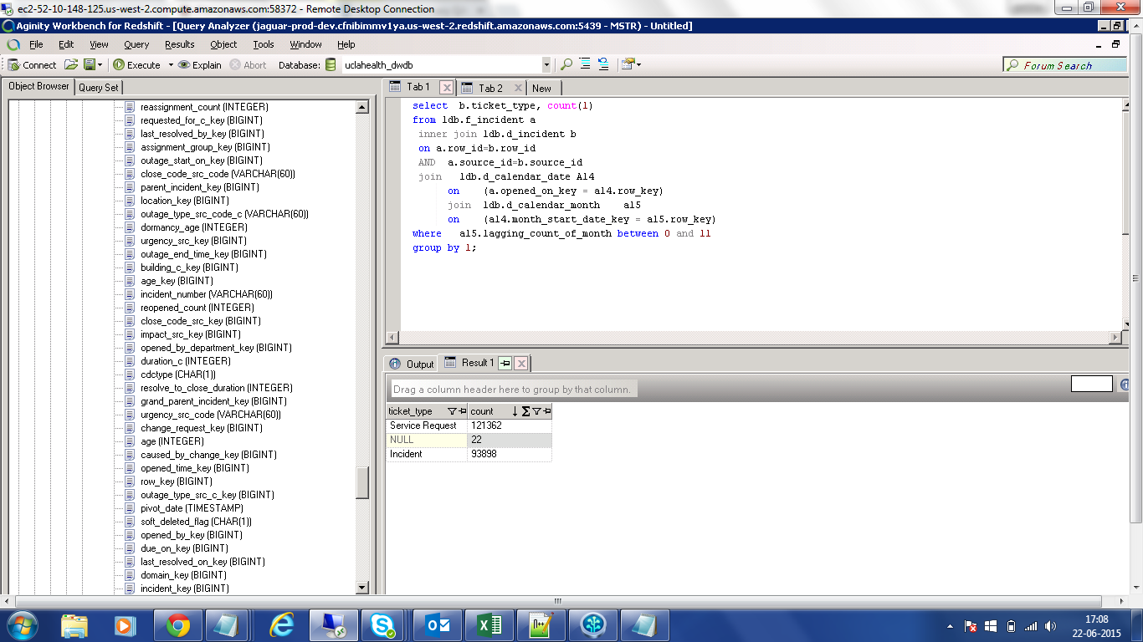

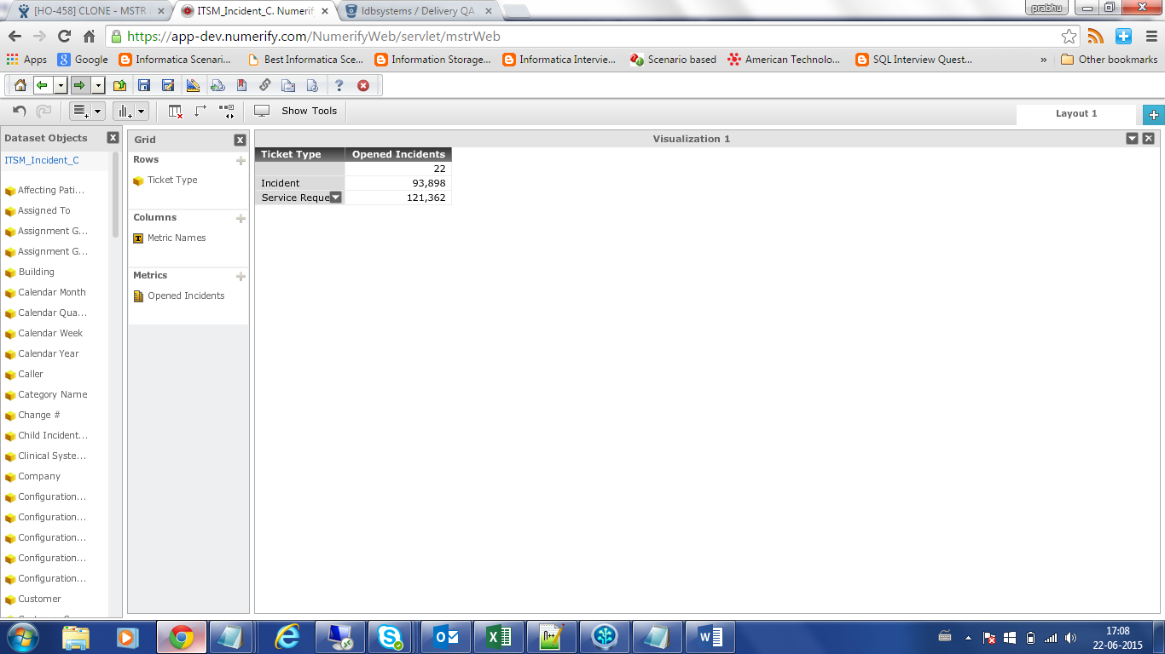

INCIDENT_TYPE:

select b. incident_type , count(1)

from uclahealth_mdwdb.f_incident a

inner join uclahealth_mdwdb.d_incident b

on a.row_id=b.row_id

and a.source_id=b.source_id

join ldb.d_calendar_date A14

on (a.opened_on_key = a14.row_key)

join ldb.d_calendar_month a15

on (a14.month_start_date_key = a15.row_key)

where a15.lagging_count_of_month between 0 and 11

group by 1;

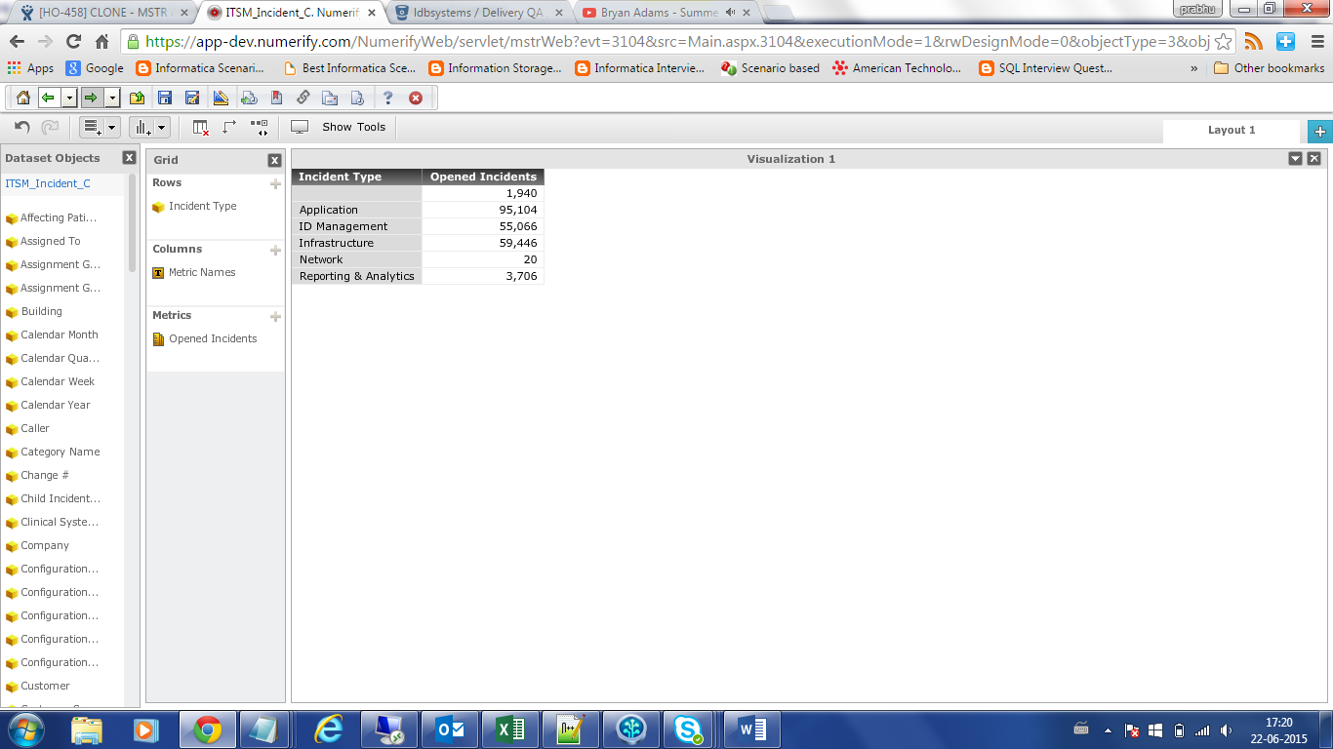

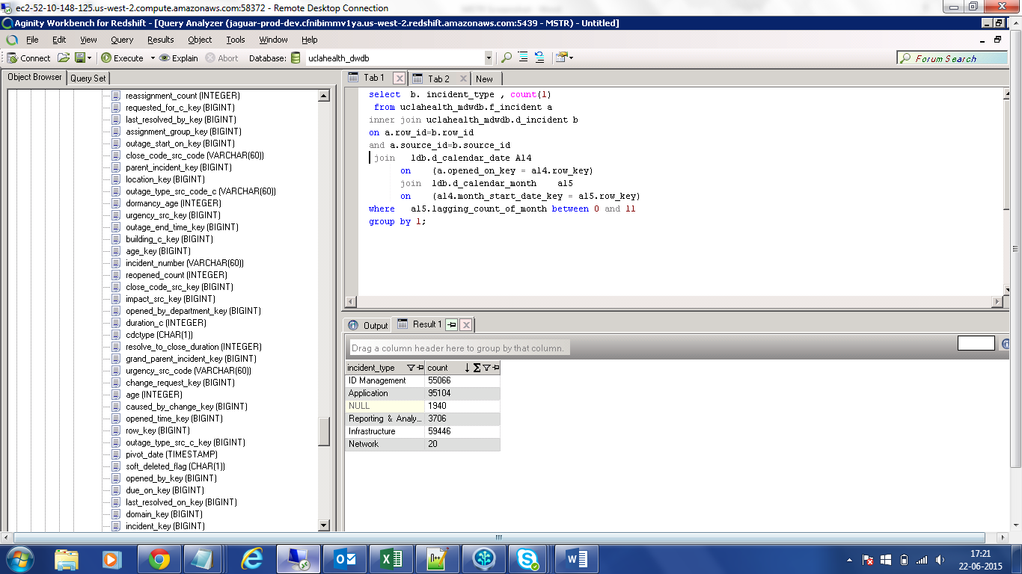

DURATION_C

select duration_c/Resolved_Incidents from

( Select count(a11.row_key) AS Resolved_Incidents,

sum((a11.duration_c) / 86400.0) AS duration_c

from ldb.f_incident a11

join ldb.d_calendar_date a111

on (a11.opened_on_key = a111.row_key)

join ldb.d_calendar_month a112

on (a111.month_start_date_key = a112.row_key)

where a112.lagging_count_of_month between 0 and 11)

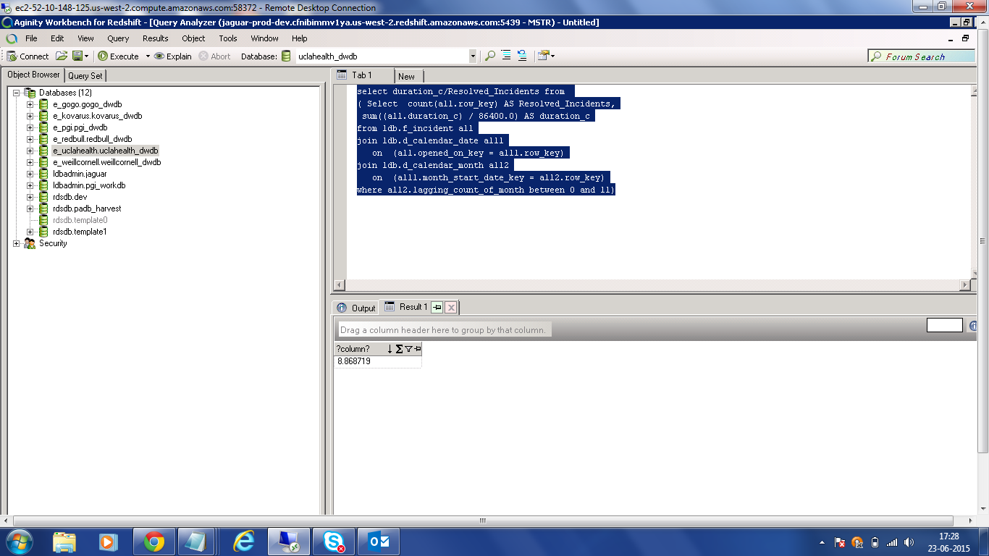

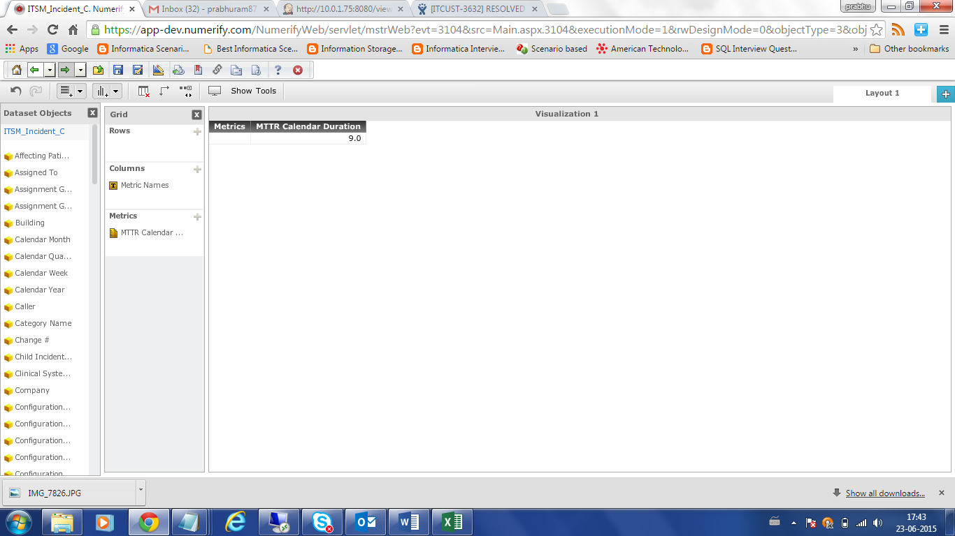

CHILD_INCIDENT_COUNT:

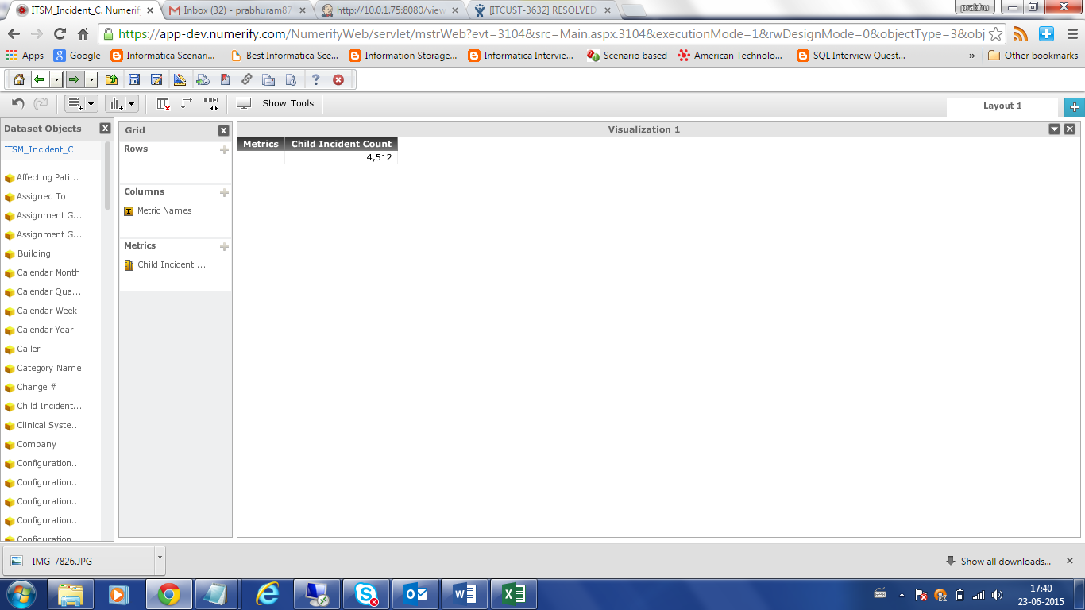

Select

SUM(CHILD_INCIDENT_COUNT_C)

from ldb.f_incident a11

join ldb.d_calendar_date a111

on (a11.opened_on_key = a111.row_key)

join ldb.d_calendar_month a112

on (a111.month_start_date_key = a112.row_key)

where a112.lagging_count_of_month between 0 and 11)

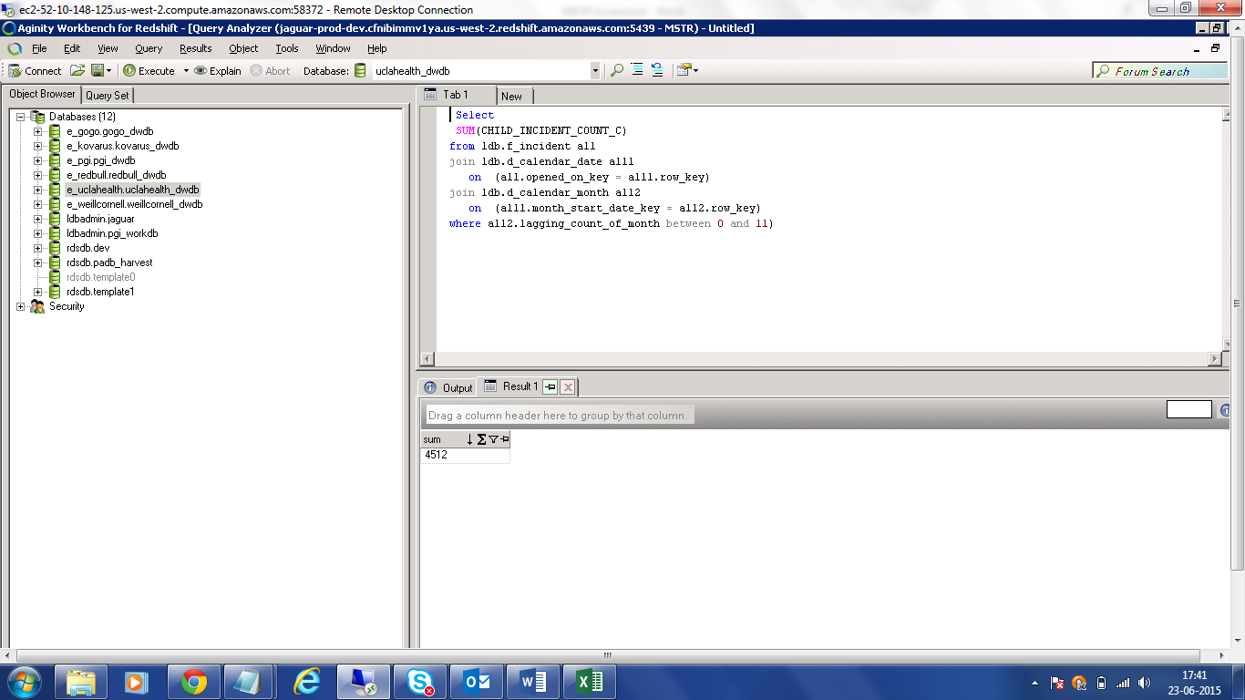

REPRIORTIZATION COUNT:

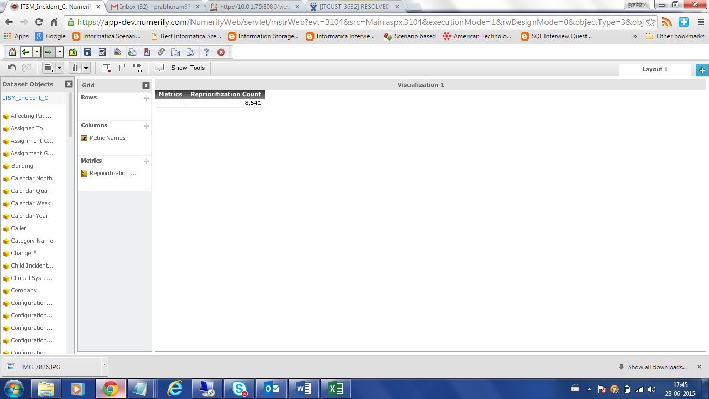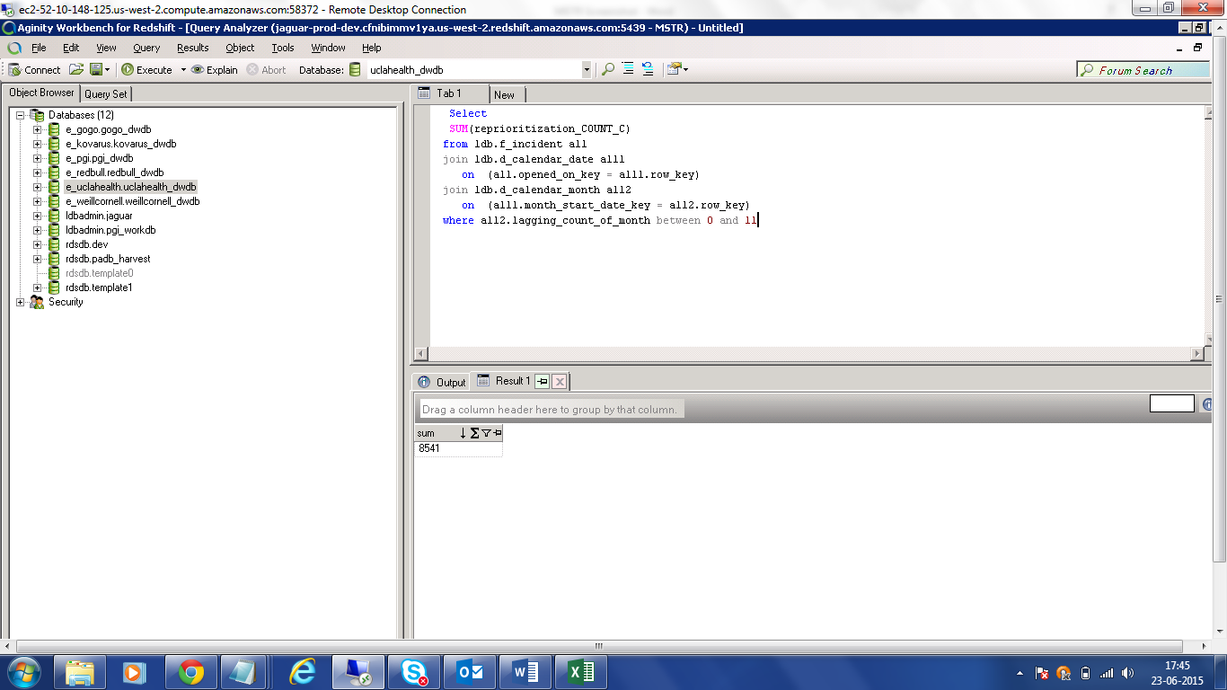

PHYSICIAN FLAG:

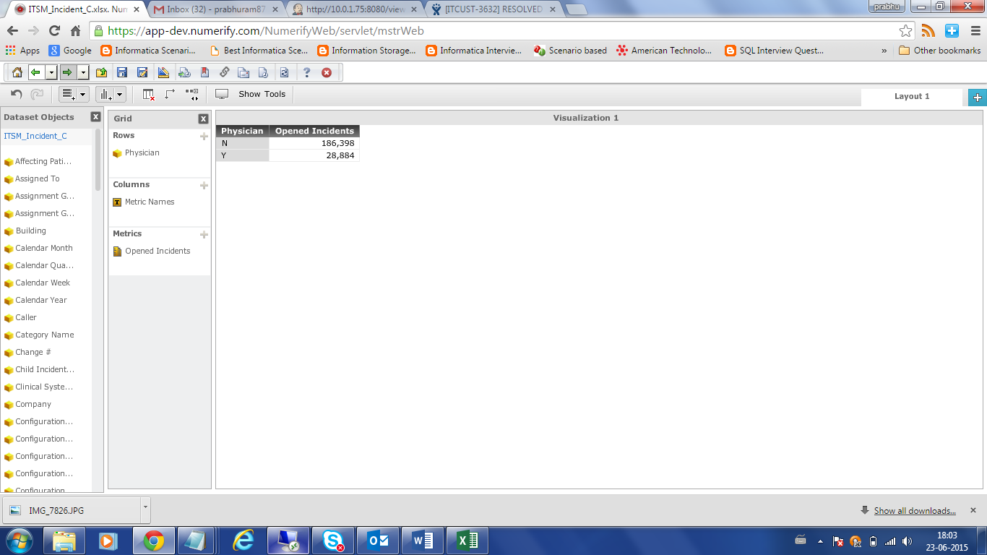

select b. physician_flag_c

, count(1)

from uclahealth_mdwdb.f_incident a

inner join uclahealth_mdwdb.d_incident b

on a.row_id=b.row_id

and a.source_id=b.source_id

join ldb.d_calendar_date A14

on (a.opened_on_key = a14.row_key)

join ldb.d_calendar_month a15

on (a14.month_start_date_key = a15.row_key)

where a15.lagging_count_of_month between 0 and 11

group by 1;

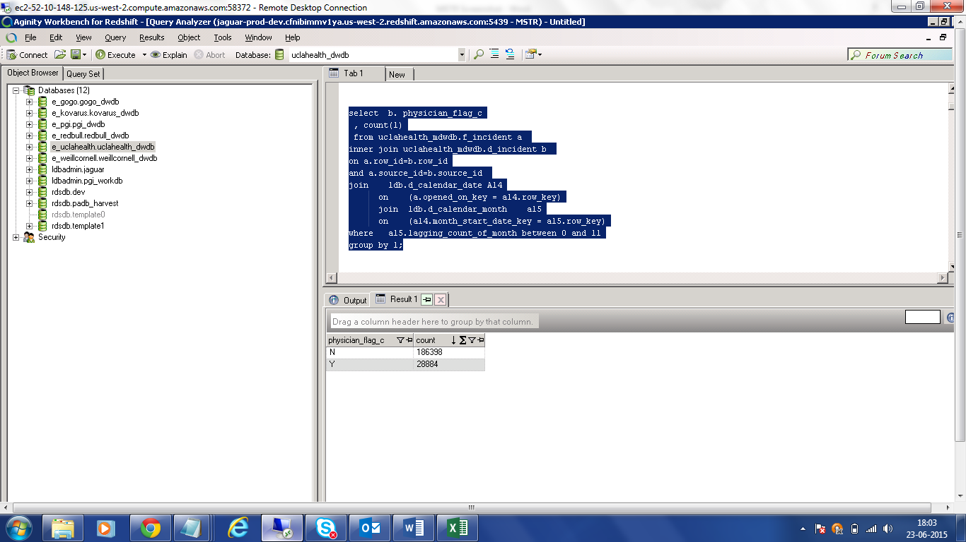

AFFECTING PATIENT SAFETY:

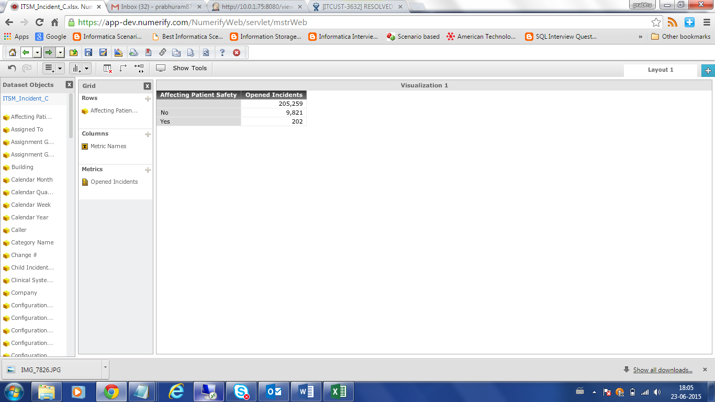

select b. patient_safety_c

, count(1)

from uclahealth_mdwdb.f_incident a

inner join uclahealth_mdwdb.d_incident b

on a.row_id=b.row_id

and a.source_id=b.source_id

join ldb.d_calendar_date A14

on (a.opened_on_key = a14.row_key)

join ldb.d_calendar_month a15

on (a14.month_start_date_key = a15.row_key)

where a15.lagging_count_of_month between 0 and 11

group by 1;

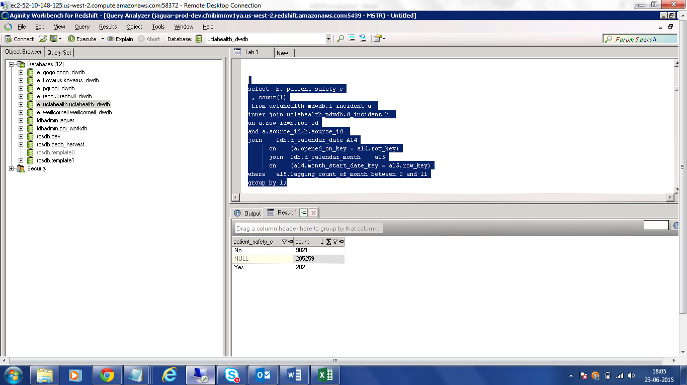

MAJOR OUTAGE:

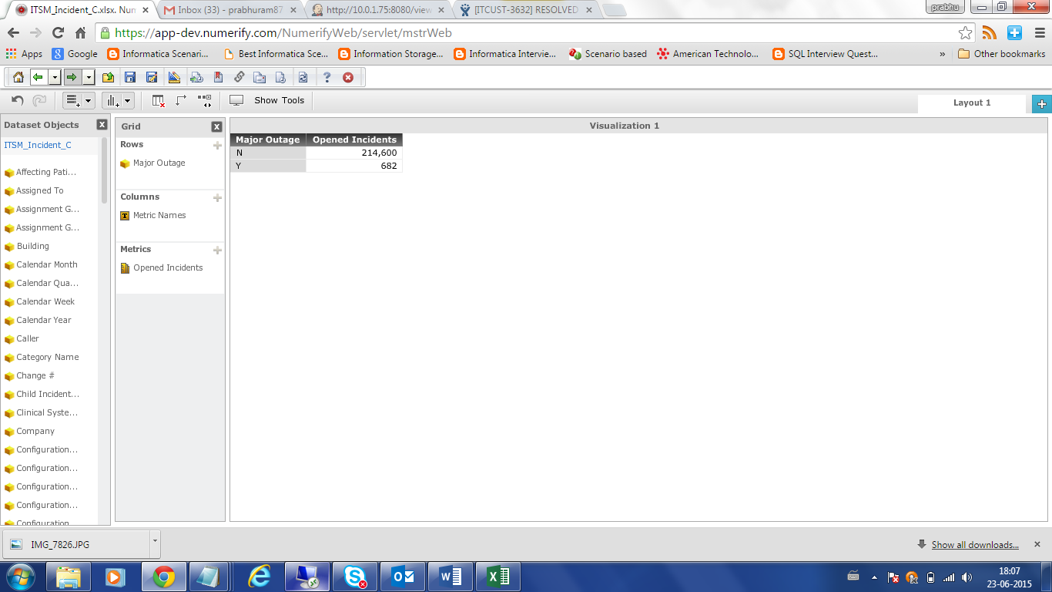

select outage_flag_c , count(1)

from uclahealth_mdwdb.f_incident a

inner join uclahealth_mdwdb.d_incident b

on a.row_id=b.row_id and a.source_id=b.source_id

join ldb.d_calendar_date A14

on (a.opened_on_key = a14.row_key)

join ldb.d_calendar_month a15

on (a14.month_start_date_key = a15.row_key)

where a15.lagging_count_of_month between 0 and 11

group by 1;

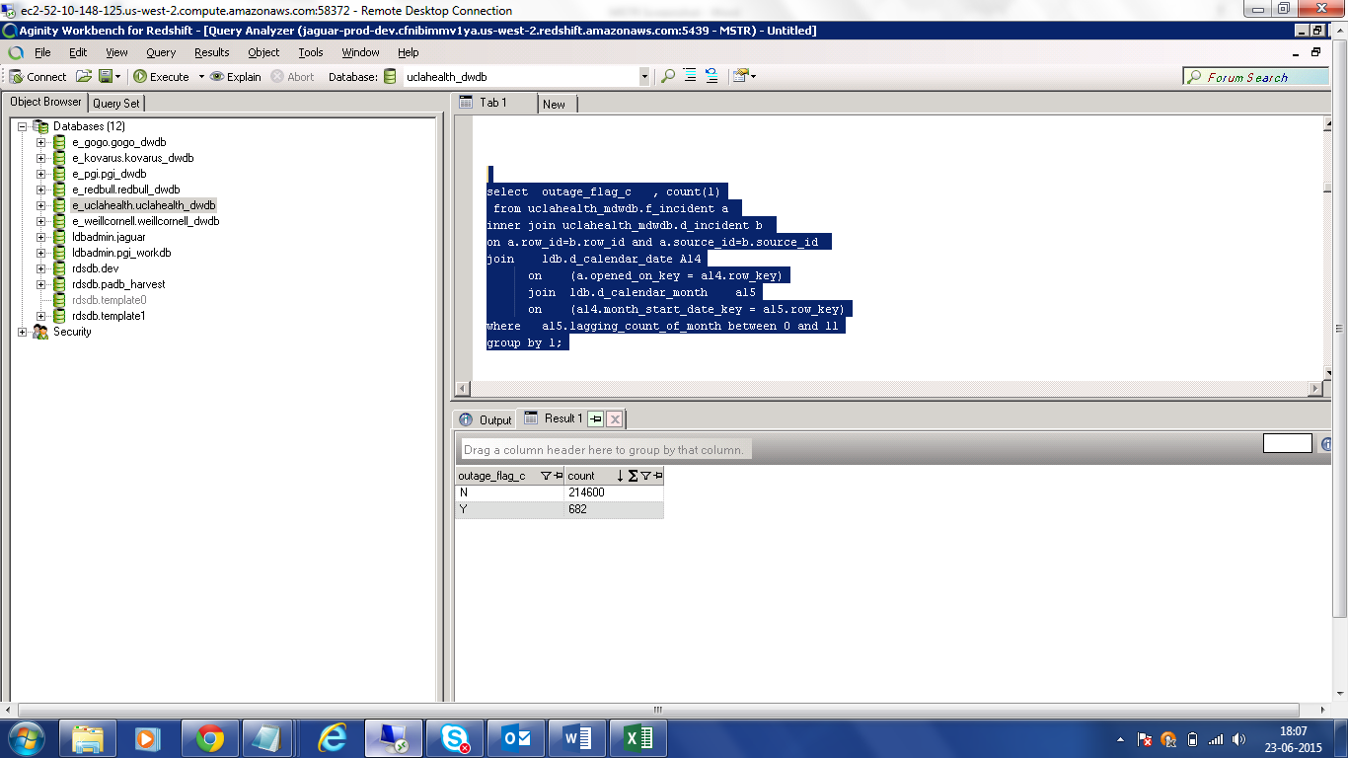

HD FIRST CALL:

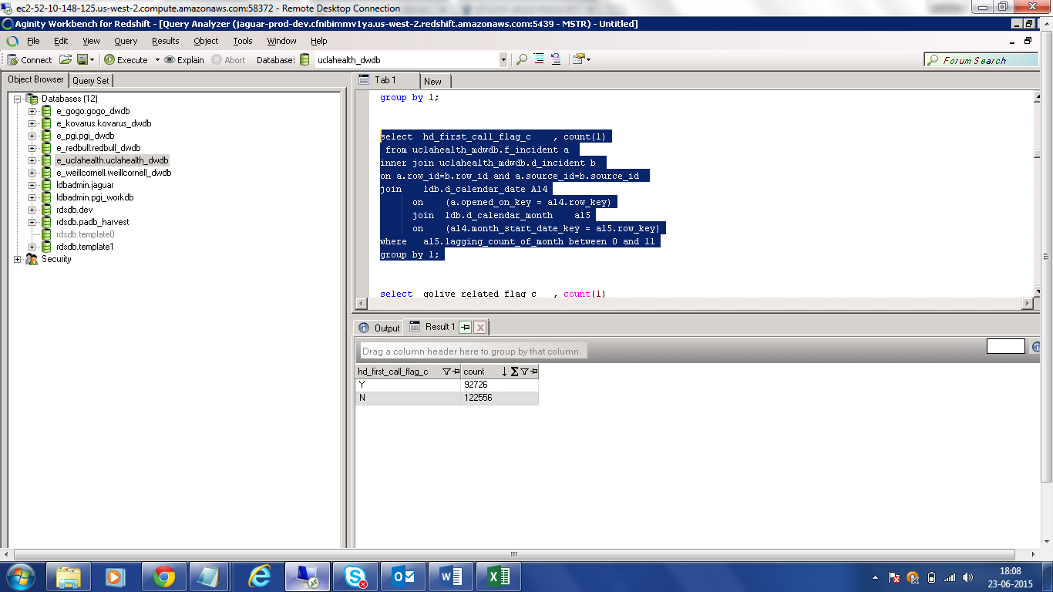

select hd_first_call_flag_c , count(1)

from uclahealth_mdwdb.f_incident a

inner join uclahealth_mdwdb.d_incident b

on a.row_id=b.row_id and a.source_id=b.source_id

join ldb.d_calendar_date A14

on (a.opened_on_key = a14.row_key)

join ldb.d_calendar_month a15

on (a14.month_start_date_key = a15.row_key)

where a15.lagging_count_of_month between 0 and 11

group by 1;

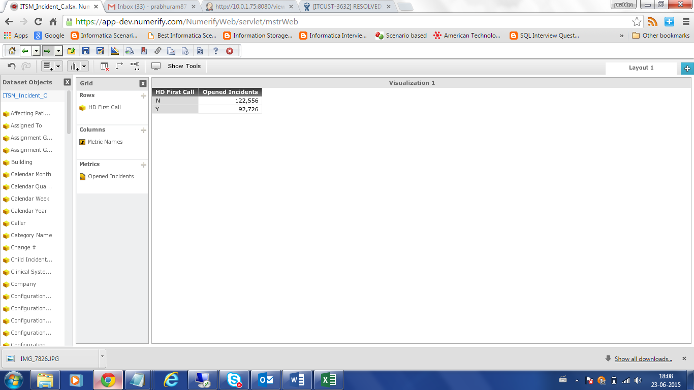

GOLIVE RELATED:

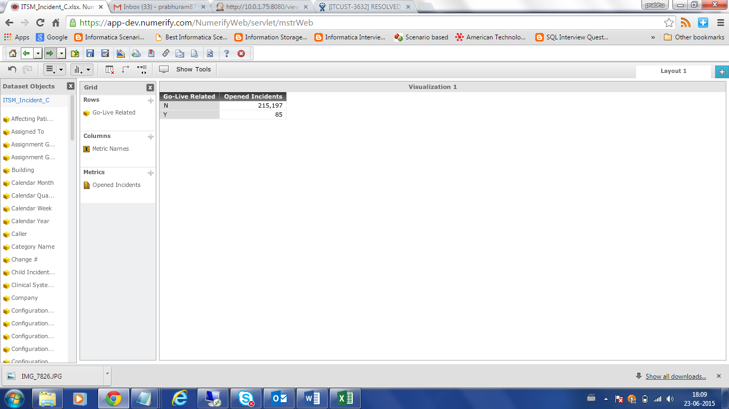

select golive_related_flag_c , count(1)

from uclahealth_mdwdb.f_incident a

inner join uclahealth_mdwdb.d_incident b

on a.row_id=b.row_id and a.source_id=b.source_id

join ldb.d_calendar_date A14

on (a.opened_on_key = a14.row_key)

join ldb.d_calendar_month a15

on (a14.month_start_date_key = a15.row_key)

where a15.lagging_count_of_month between 0 and 11

group by 1;

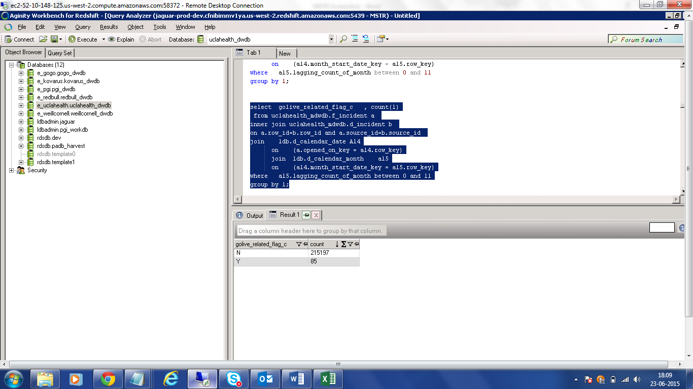

CLINICAL SYSTEM OUTAGE:

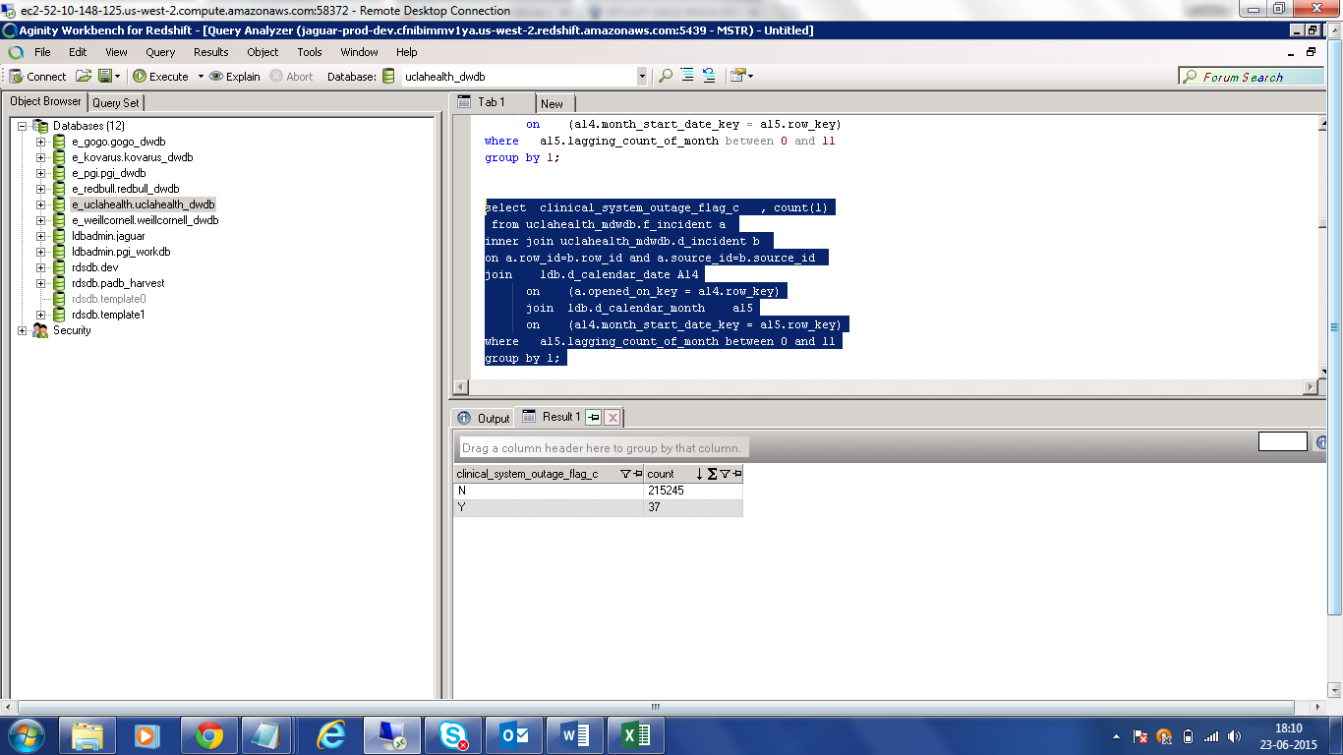

select clinical_system_outage_flag_c , count(1)

from uclahealth_mdwdb.f_incident a

inner join uclahealth_mdwdb.d_incident b

on a.row_id=b.row_id and a.source_id=b.source_id

join ldb.d_calendar_date A14

on (a.opened_on_key = a14.row_key)

join ldb.d_calendar_month a15

on (a14.month_start_date_key = a15.row_key)

where a15.lagging_count_of_month between 0 and 11

group by 1;



REPRIOROTIZATION COUNT :

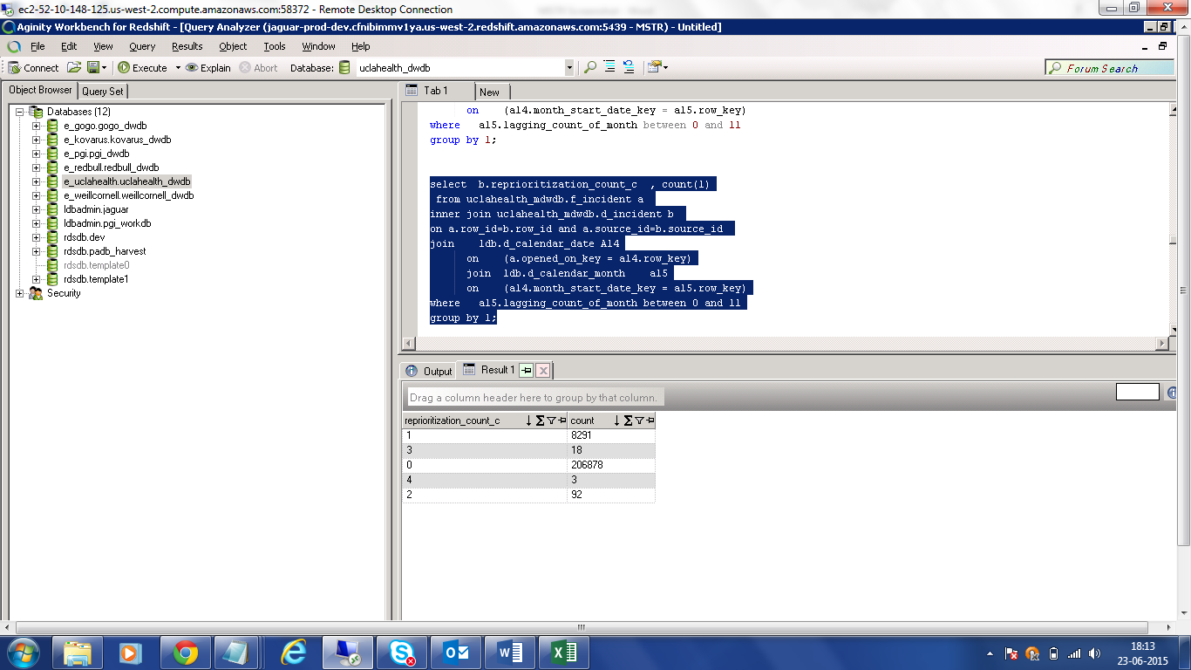

select b.reprioritization_count_c , count(1)

from uclahealth_mdwdb.f_incident a

inner join uclahealth_mdwdb.d_incident b

on a.row_id=b.row_id and a.source_id=b.source_id

join ldb.d_calendar_date A14

on (a.opened_on_key = a14.row_key)

join ldb.d_calendar_month a15

on (a14.month_start_date_key = a15.row_key)

where a15.lagging_count_of_month between 0 and 11

group by 1;

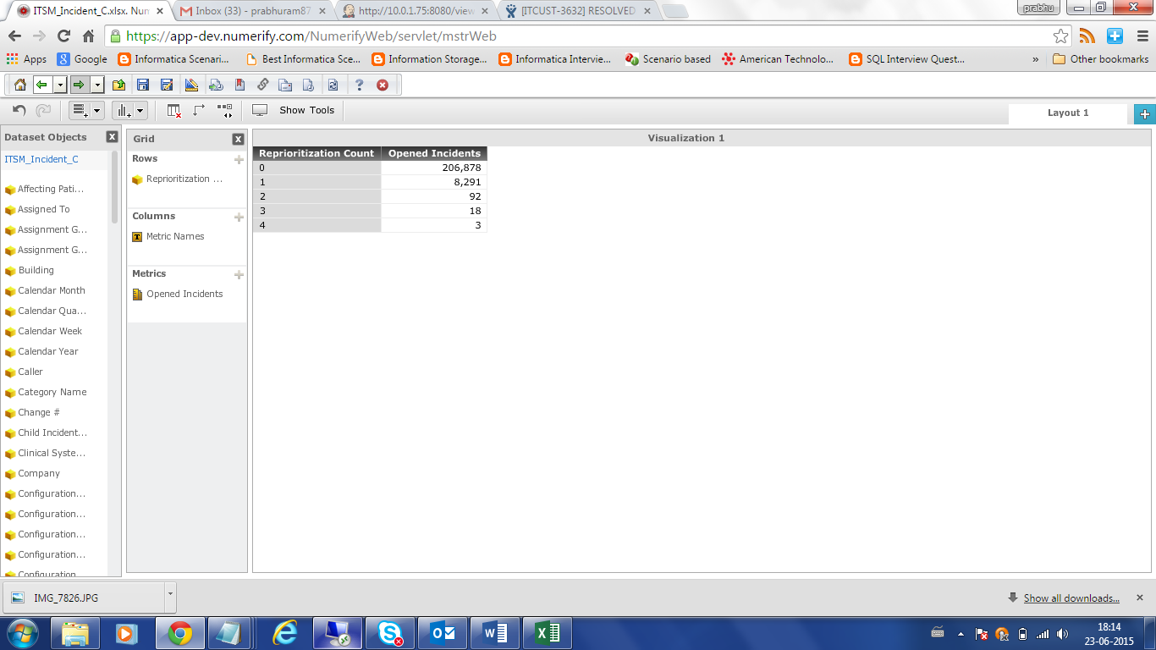

OUTAGE_TYPE:

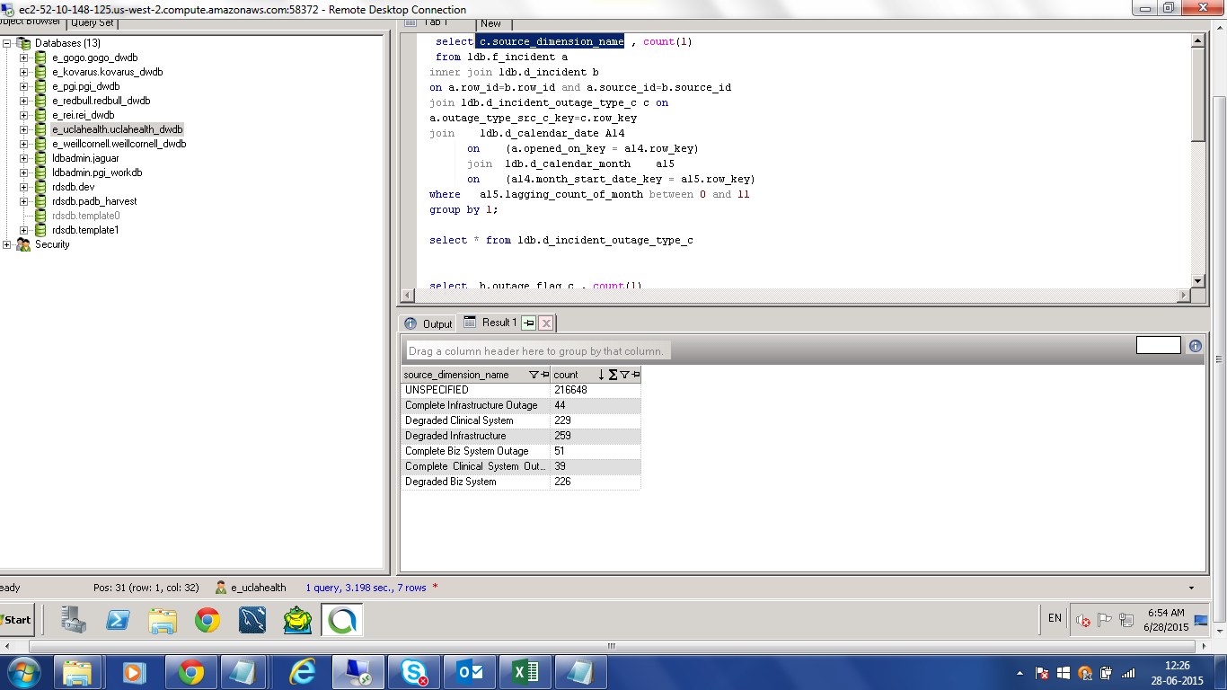

select c.source_dimension_name , count(1)

from ldb.f_incident a

inner join ldb.d_incident b

on a.row_id=b.row_id and a.source_id=b.source_id

join ldb.d_incident_outage_type_c c on

a.outage_type_src_c_key=c.row_key

join ldb.d_calendar_date A14

on (a.opened_on_key = a14.row_key)

join ldb.d_calendar_month a15

on (a14.month_start_date_key = a15.row_key)

where a15.lagging_count_of_month between 0 and 11

group by 1;

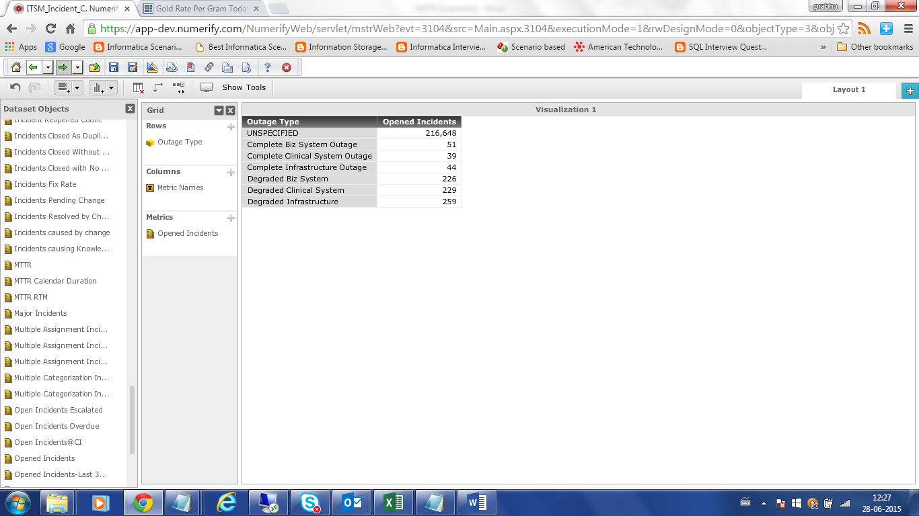

OUTAGE TYPE :CLOSED:

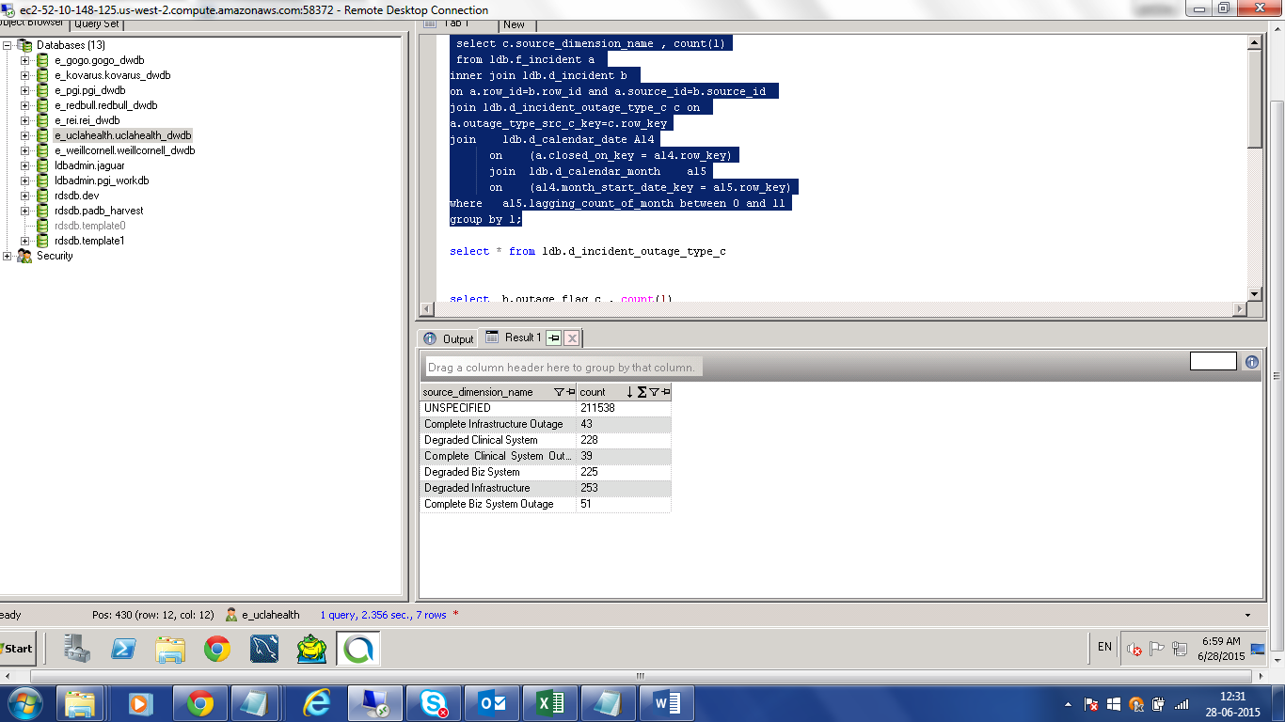

select c.source_dimension_name , count(1)

from ldb.f_incident a

inner join ldb.d_incident b

on a.row_id=b.row_id and a.source_id=b.source_id

join ldb.d_incident_outage_type_c c on

a.outage_type_src_c_key=c.row_key

join ldb.d_calendar_date A14

on (a.closed_on_key = a14.row_key)

join ldb.d_calendar_month a15

on (a14.month_start_date_key = a15.row_key)

where a15.lagging_count_of_month between 0 and 11

group by 1;

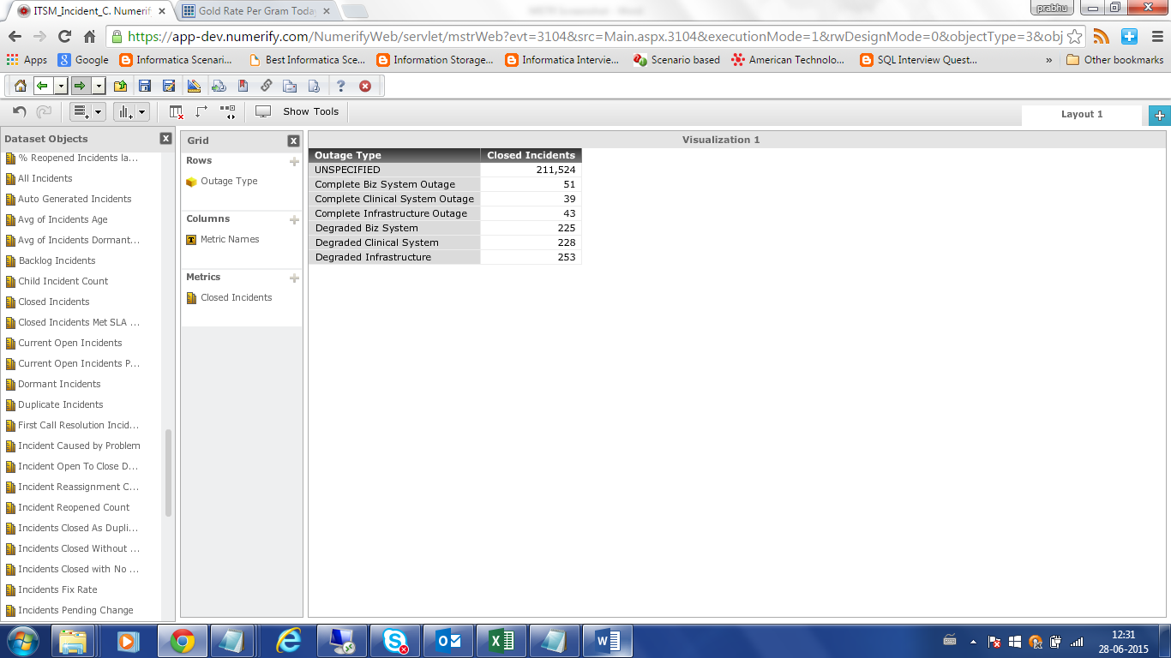

RESOLVED:

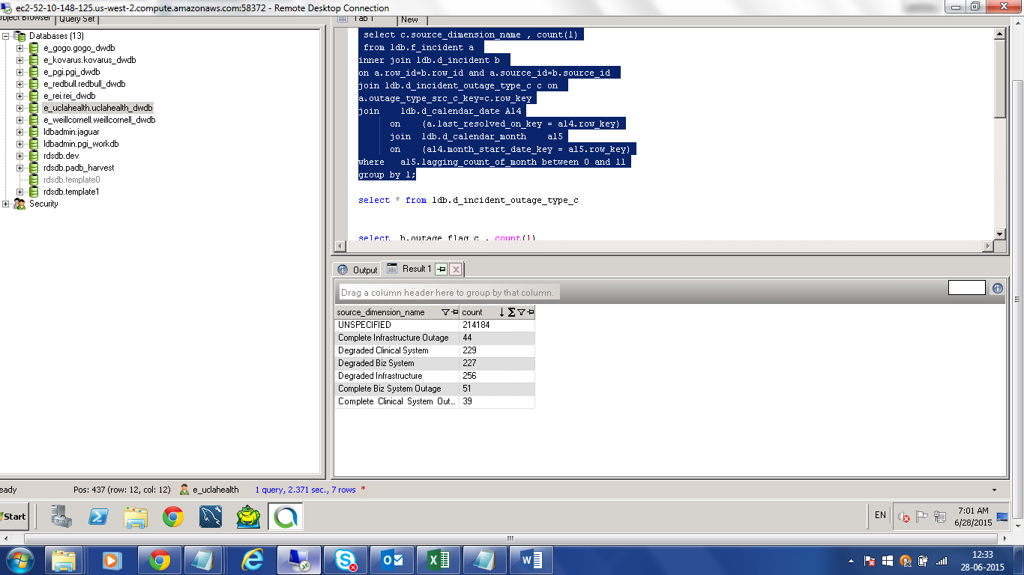

select c.source_dimension_name , count(1)

from ldb.f_incident a

inner join ldb.d_incident b

on a.row_id=b.row_id and a.source_id=b.source_id

join ldb.d_incident_outage_type_c c on

a.outage_type_src_c_key=c.row_key

join ldb.d_calendar_date A14

on (a.last_resolved_on_key = a14.row_key)

join ldb.d_calendar_month a15

on (a14.month_start_date_key = a15.row_key)

where a15.lagging_count_of_month between 0 and 11

group by 1;

